

Lab 4
COMP6042_26213 Operating Systems in Practice
Student ID: R00201303
Date: 26.04.2022
Group: COMP1D-Y
Question1:
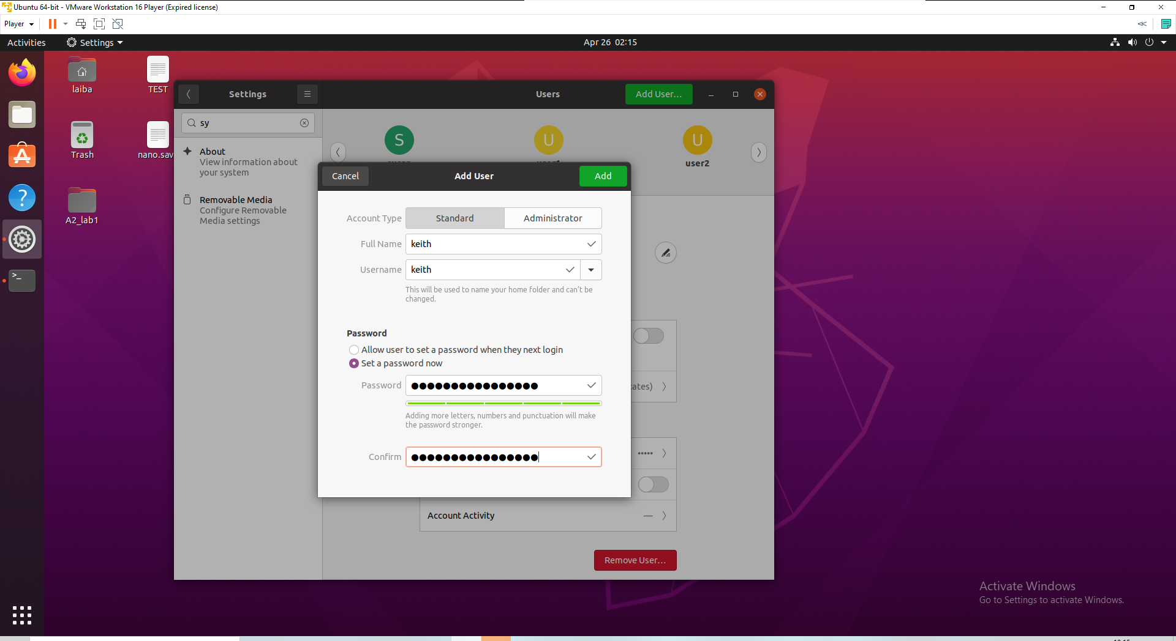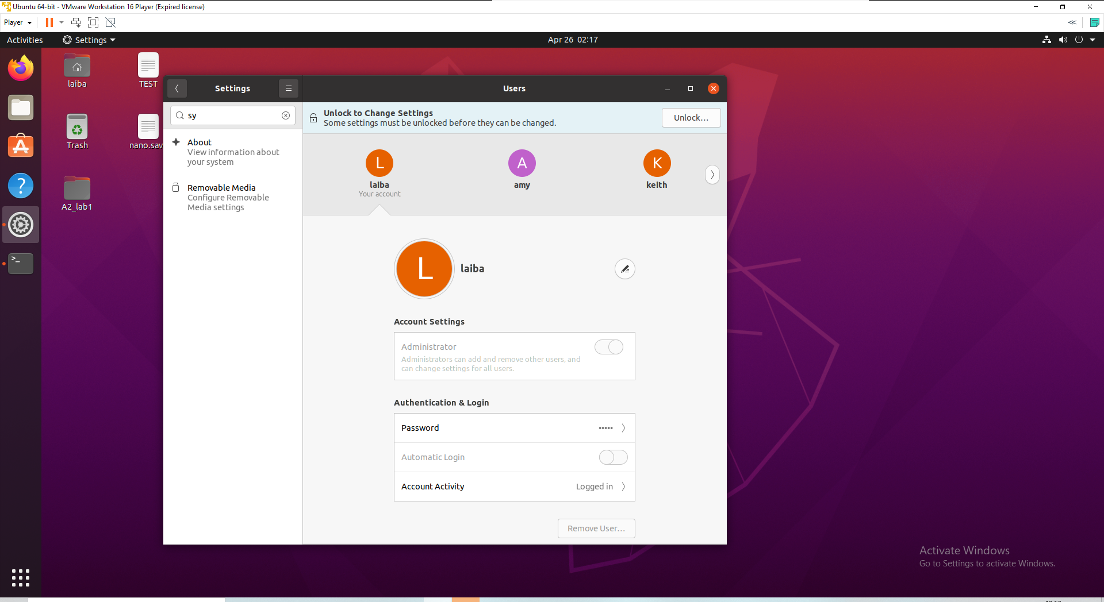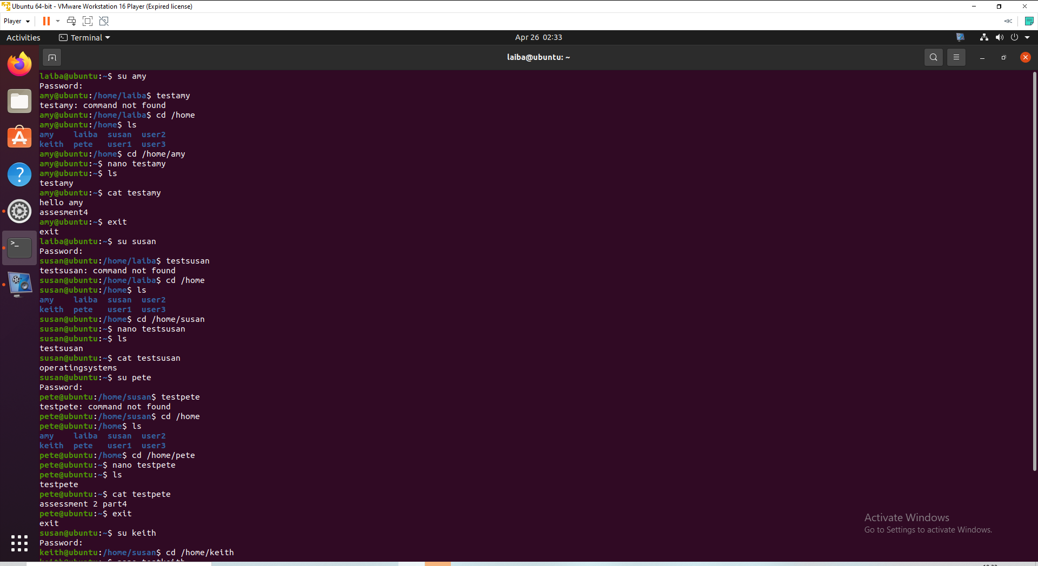
- Describe the su command:
Su (short for substitute or switch user) is a command-line tool that allows you to perform commands with the capabilities of another user, usually the root user. Switching to the administrative account in the current login session is as simple as typing su. This is particularly useful when the root user is not permitted to connect in through ssh or the GUI display manager.

Question2: 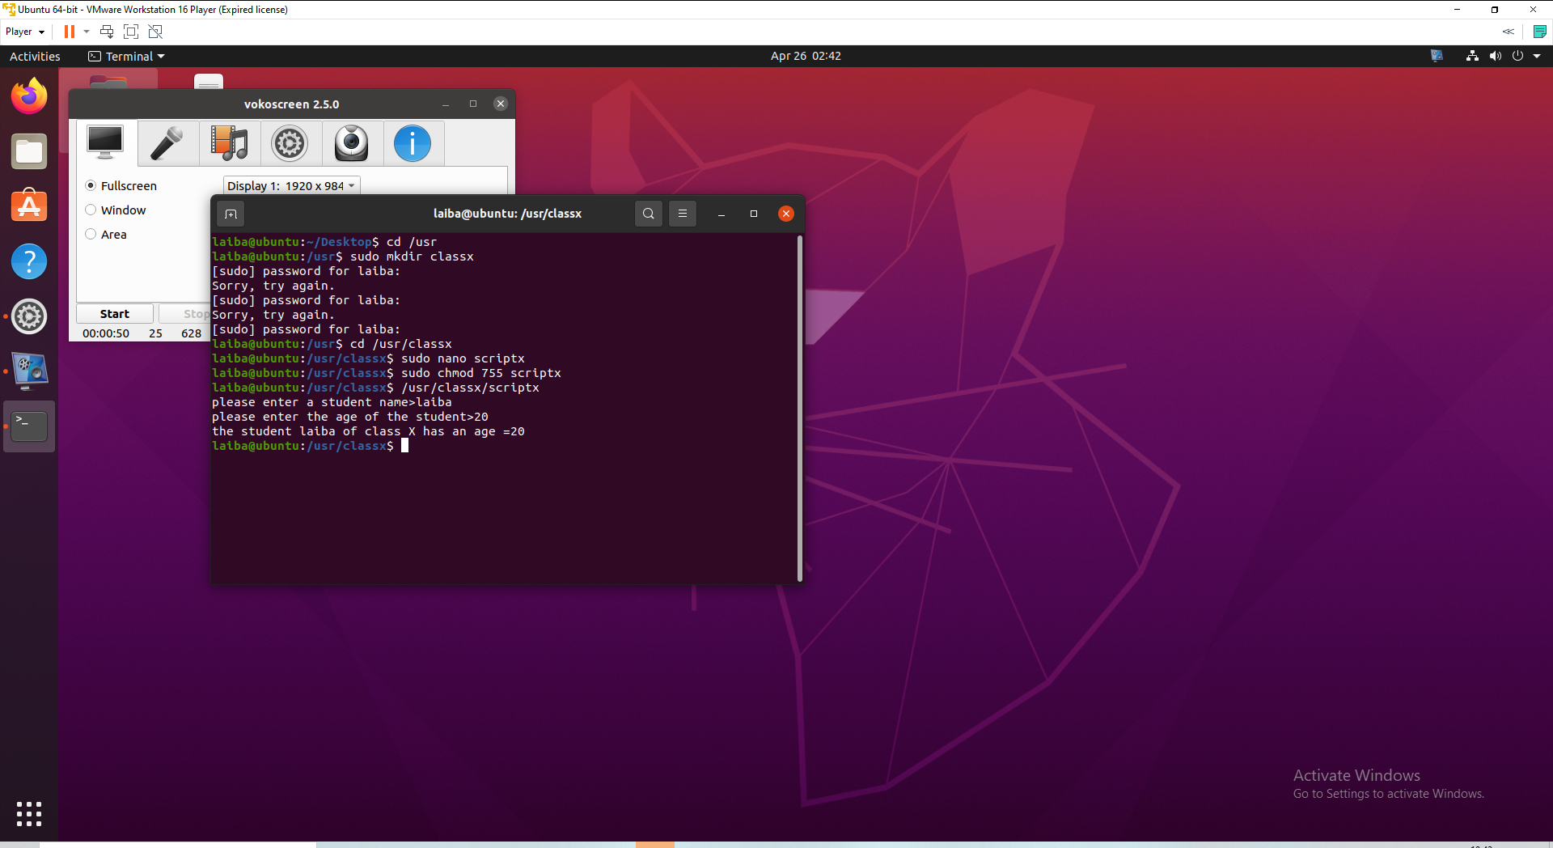
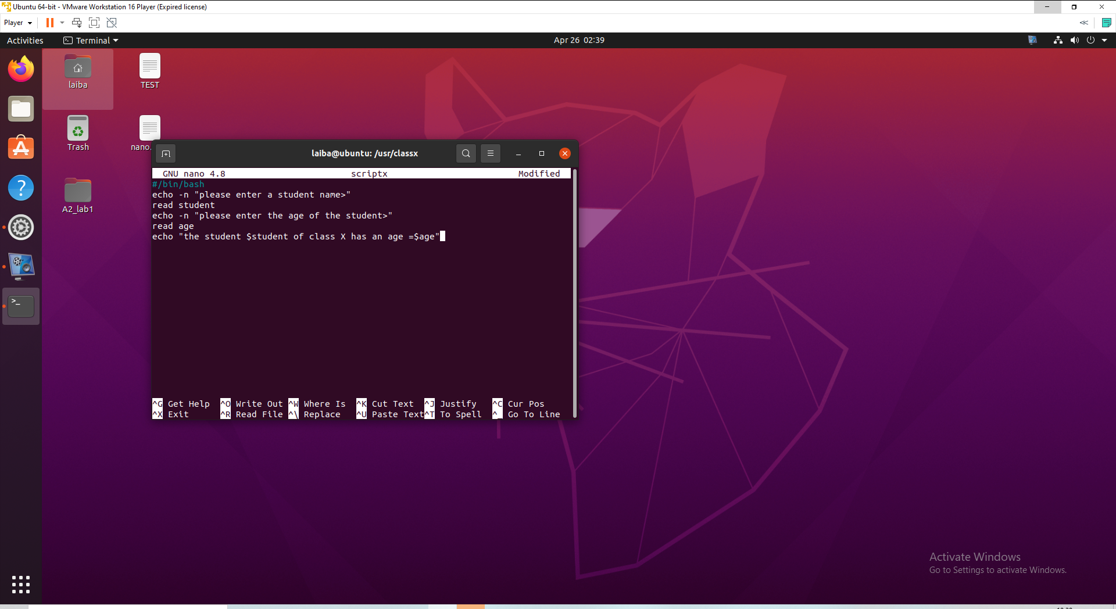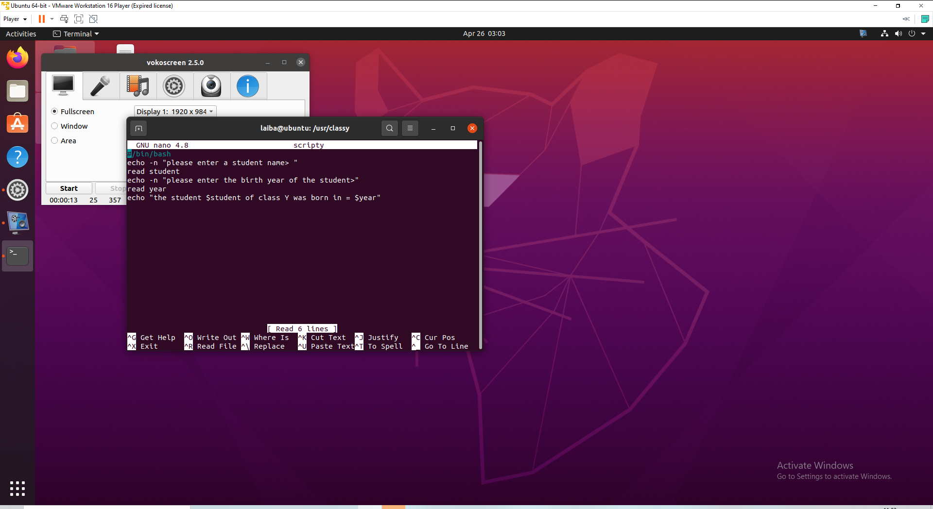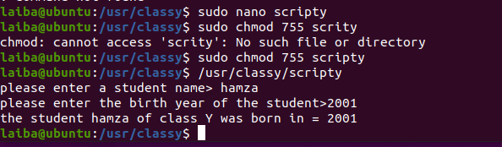
Question3:

Create two groups:
$sudo groupadd classx
$sudo groupadd classy
Check the group file to see these are created,
($cat /etc/group) .
$sudo usermod –a –G classx amy
$ sudo usermod –a –G classx pete
$sudo usermod –a –G classy keith
$ sudo usermod –a –G classy susan

